Andrew Drugs

Michael

November 11, 2017

setwd("C:/Users/Michael Streyle/Desktop")  
library(nplr)

## Warning: package 'nplr' was built under R version 3.4.3

andrew <- read.csv('andrew.csv')  
attach(andrew)  
  
  
  
  
np2 <- nplr(y=Their.curve, x=Ave, npars = 4)

## Warning: 25% of your y values fall outside the range [0, 1]

## - any results output may not be representative.

## - be sure you are using y-values as proportions.

##

plot(np2, main="ANDREW")

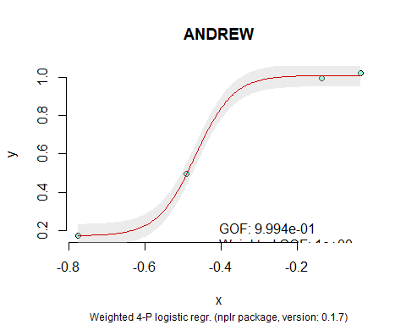

summary(np2)

## value  
## npar 4  
## params.bottom 1.73399e-01  
## params.top 1.00909e+00  
## params.xmid -4.67397e-01  
## params.scal 8.76324e+00  
## params.s 1.00000e+00  
## GOF 9.99424e-01  
## weightedGOF 9.99998e-01  
## stdErr 0.01205888  
## weighted stdErr 0.0009548566  
## trapezoid 0.495682  
## Simpson 0.491301  
## xInfl -0.467397  
## yInfl 0.591246  
## Log10(IC50) -0.4893952  
## IC50 3.24045e-01  
## [95%] [3.20265e-01 | 3.27793e-01]  
## date (Y-m-d) 2017-12-11  
## nplr version 0.1.7 (2016-12-25)  
## R version 3.4.1 (2017-06-30)

getEstimates(object = np2, targets = c(0.16695,0.3233,0.73355,0.92795, 0.86285, 0.8075, 0.8049))

## Warning: One (or more) of the provided values were less or equal to the  
## estimated bottom asymptote.

## These values have been replaced by the minimal possible value the model can estimate.

## y x.025 x x.975  
## 1 0.1749998 0.1340657 0.1669500 0.2271074  
## 2 0.3233000 0.2813089 0.2865792 0.2915919  
## 3 0.7335500 0.3652659 0.3696267 0.3743420  
## 4 0.9279500 0.4278042 0.4396572 0.4548796  
## 5 0.8628500 0.3995077 0.4068648 0.4147433  
## 6 0.8075000 0.3828260 0.3885039 0.3942735  
## 7 0.8049000 0.3824335 0.3877543 0.3936387